

**“SIMPLE TESTER FOR OPEATIONAL AMPLIFIERS”**

A MINI PROJECT REPORT

*Submitted by*

KURAPATI SAI SWATHI (1NH18EC060)

CHALLA KUNDANA SAI (INH18EC022)

BALAJI A (INH18EC018)

SATYA MANOJ BASINA AGASTYA (INH17EC140)

*In partial fulfillment for the award of the degree of*

**BACHELOR OF ENGINEERING**

**IN**

**ELECTRONICS AND COMMUNICATION**

NEW HORIZON COLLEGE OF ENGINEERING

DEPARTMENT OF ELECTRONICS AND

COMMUNICATION ENGINEERING



**CERTIFICATE**

Certified that the mini project work entitled “**SIMPLE TESTER FOR OPEATIONAL AMPLIFIERS**” carried out by**, KURAPATI SAI SWATHI (1NH18EC060), CHALLA KUNDANA SAI (INH18EC022), BALAJI A (INH18EC018), SATYA MANOJ BASINA AGASTYA (INH17EC140)** bonafide students of Electronics and Communication Department, New Horizon College of Engineering, Bangalore.

The mini project report has been approved as it satisfies the academic requirements in respect of mini project work prescribed for the said degree.

Project guide HOD ECE

Mr. Deepak Kumar S Dr. Sanjeev Sharma

Senior Assistant Professor B. Tech M. Tech PhD

Dept of ECE NHCE

NHCE

------------------------- ------------------------

**External Viva**

Name of Examiner Signature with Date

1.

2.

**ACKNOWLEDGEMENT**

The satisfaction that accompany the successful completion of any task would be, but impossible without the mention of the people who made it possible, whose constant guidance and encouragement helped us succeed.

We thank **Dr. Mohan Manghnani**, Chairman of **New Horizon Educational Institution**, for providing necessary infrastructure and creating good environment.

We also record here the constant encouragement and facilities extended to us by **Dr. Manjunatha**, Principal, NHCE and **Dr. Sanjeev Sharma**, head of the department of Electronics and Communication Engineering. We extend sincere gratitude to them.

We sincerely acknowledge the encouragement, timely help and guidance to us by our beloved guide **Mr. Deepak Kumar S** to complete the project within stipulated time successfully.

Finally, a note of thanks to the teaching and non-teaching staff of electronics and communication department for their co-operation extended to us, who helped us directly or indirectly in this successful completion of mini project.

**KURAPATI SAI SWATHI (1NH18EC060)**

**CHALLA KUNDANA SAI (INH18EC022)**

**BALAJI A (INH18EC018)**

**SATYA MANOJ BASINA AGASTYA (INH17EC140)**

**TABLE OF CONTENTS**

|  |  |  |
| --- | --- | --- |
| CHAPTER NUMBER | CHAPTER NAME | PAGE NUMBER |
| 1 | INTRODUCTION | 8-10 |
| 2 | LITERATURE SURVEY | 11 |
| 3 | EXISTING SYSTEM AND PROBLEM STATEMENT | 12-13 |
| 4 | PROPOSED SYSTEM | 14-16 |
| 5 | HARDWARE DESCRIPTION | 17-29 |
| 6 | RESULT AND DISSCUSSION | 30 |
| 7 | ADVANTAGES AND APPLICATIONS |  |
| 8 | FUTURE SCOPE |  |
| 9 | CONCLUSION |  |

**LIST OF FIGURES**

**LIST OF TABLES**

**ABSTRACT**

Testing before implementation is an important step in the building of a fully functioning circuit. Testing of the basic blocks of a circuit ensure that the design after being implemented is working as per the user’s requirements. This testing can be done in various methods and the output of such tester circuits is mostly in binary, that is either high or low. Simple tester circuits revolve around the design where in the output is given by an LED. If the LED is on, the IC is functioning as per the requirements else the IC is to be replaced. This IC can now be used in larger designs. The circuit implemented here can be used to test two single output operational amplifier’s and 1 dual output operational amplifier at once. The output of the circuit is based on the frequency response given by the circuit. The inputs to this circuit is nothing but plugging in the IC to be tested in the slot and completing the conducting paths using switches.

Furthermore, this project revolves around the importance of an operational amplifier characteristic that is slew rate. This project is the simplest and the most optimized version of an IC tester.

CHAPTER 1

INTRODUCTION

Operational amplifiers are a direct coupled amplifier having very high gain. Any operational amplifier has the following features/specifications which are to be met for the proper function of the amplifier. The specifications are listed as follows:

* Open loop gain is the gain of the circuit when there is no feedback path introduced. Ideally it is infinite whereas practically it is very high. Typically, an op-amp has the gain 100000.
* Input impedance is the measure of the opposition to current given by the circuit (resistance and reactance). Ideally it is infinity, thus allowing 0 current into the device. Practically the value is very high (in Mega ohms) thus allowing very little current into the device (in micro amps)
* Output impedance also referred to as source impedance, it is the opposition of the current flow into the load. Ideally it is zero, practically it is very high.
* Common mode rejection ratio of a differential amplifier is a ratio used to depict the ability of the device to reject common mode signals. Ideally this value is infinite, practically it is very high. The higher the value of CMRR the better.
* Difference in the upper and lower frequencies in a continuous band of frequencies is known as band width. It is measured in hertz (Hz) ideally it is infinite, practically it is very high.
* Slew rate can be defined as the rate of change of voltage or current with respect to unit time. It usually expressed in volts/ second or ampere/second. Ideally the value of slew rate is infinite, practically it is very high.

There are two main rules or criteria for any op-amp.

1. The voltage at the input terminals is made same in a closed loop configuration
2. The input terminals draw no current i.e. No current enters the operational amplifier.

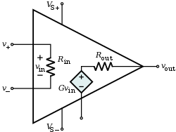

A basic operational amplifier has one or more differential amplifiers followed by a level translator and an output stage. To understand the testing of any IC it is essential to understand the working, internal diagram and the features of the operational amplifier.

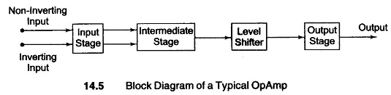

* Stage 1: It is also known as the input stage. The input stage is a dual input differential amplifier; it produces a balanced output. This stage is mainly used to provide the required voltage gain of the entire block. It ensures that the input impedance is maintained to be high which is a requirement for the proper functioning of the operational amplifier.
* Stage 2: It is also known as the intermediate stage. It produces an unbalanced output. The input to this block is the output of the previous block that is a balanced input is provided to this stage. This stage usually comprises of a differential amplifier. Since this stage is directly coupled, the DC voltage at the output of this stage is slightly above the ground potential.
* Stage 3: this stage is also known as the level shifter or the level translator. This stage is mainly used to shift the DC level of the output downward to zero level with respect to ground (reference).
* Stage 4: it is also known as the output stage. It is used to increase the output voltage swing of the final output and to provide a low output impedance. This stage usually comprises of push-pull complementary amplifiers.

A simple tester which is used to test both single and dual output operational amplifier mainly consists of a square wave oscillator. A square wave oscillator is a relaxation oscillator, the output of this is a square wave. This oscillators output is solely dependent on the time constant of the circuit. The rapid charging and discharging of the capacitors drive the operation of the circuit. A basic square wave oscillator is shown as follows

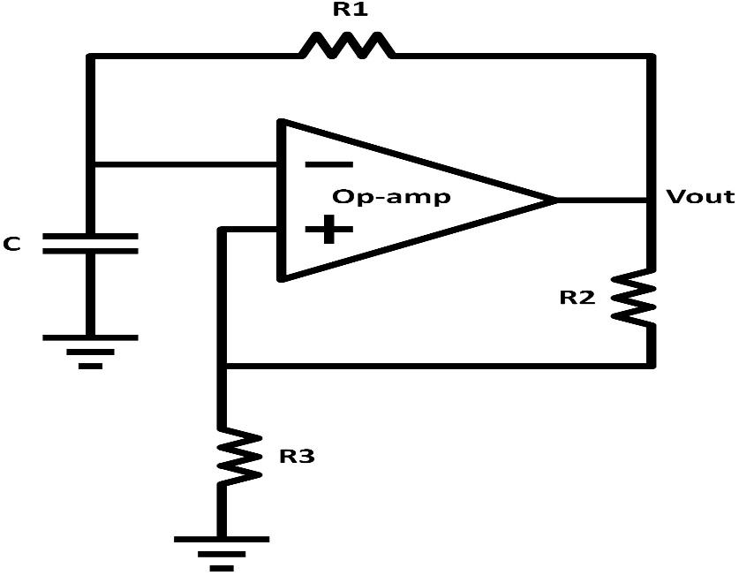

**CHAPTER 2**

**LITERATURE SURVEY**

|  |  |  |  |
| --- | --- | --- | --- |
| **Title of the paper** | **Author & Year of Publication** | **Outcome** | **Limitation** |
| Simple tester for operational amplifier | S.C. Dwivedi | Tester for op-amp | Basic tester |
| Conventional Three Op-amp IA with Resistive Feedback | Shodhganga | Classic 3  op amp IA | Buffered subtractor circuit |
| Research gate | Aduita A Gaonkar 1960 | Test for op-amp | Test and IC’s implementation |
| Elector magazine | Dirk Schemacher 2005 | Op-amp tester | Test equipment |

**CHAPTER 3**

**EXISTING SYTEM AND PROBLEM STATEMENT**

3.1 PROBLEM STATEMENT: -

Understanding, designing and implementation of tester for operational amplifier.

OBJECTIVES: -

* To understand the functionality of IC and diode.
* The sole purpose is to provide isolation and prevent circuit loading.
* Check for errors in operational amplifier prior to it’s use.

3.2 EXISTING SYSTEM: -

Circuit Diagram and Working:

Circuit is very simple with few components, that can be easily built on breadboard or on PCB.

The op-amp LM741has to be placed on right place. The led will flash or blinks if the op-amp is

in good condition. If the led remains ON or OFF continuously then the op-amp is said to be

faulty.

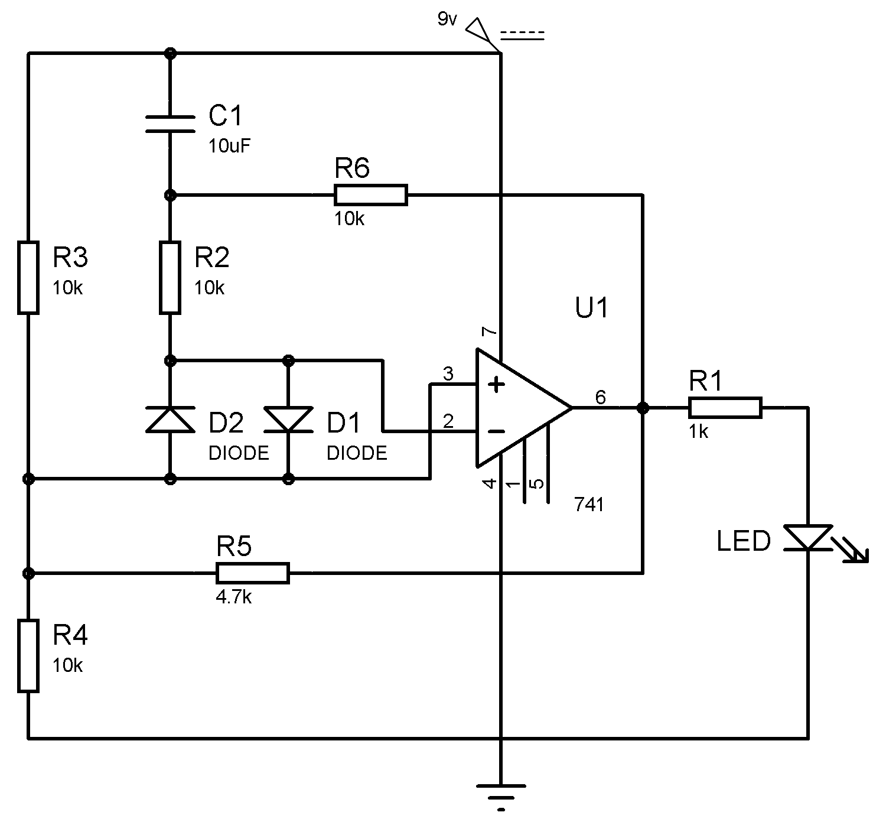

Fig 3

Working of this circuit is simple. If the op-amp is in working condition this circuit generates a

square wave at the output, resulting a blinking LED. When the circuit is switched on with the

op-amp in its place, initially voltage at non-inverting input (+) is higher than the voltage at

inverting input (-) and the output of op-amp is high. So, through R6 resistor the capacitor C1

starts charging. The output becomes low, when C1 charging exceeds the voltage at inverting

terminal. As the output goes low, the capacitor C1 starts discharging resulting in lower voltage

at inverting terminal than that of the non-inverting terminal. And the output goes high.

This process continuously and produces square wave at the output. This results in LED to blink.

**CHAPTER 4**

**PROPOSED SYSTEM**

This is a simple tester for single and dual operational amplifiers (op-amps) with square-wave oscillator. These op-amps are commonly used in different projects. You can use and reuse these, but an op-amp has to be tested before use in new and different projects.

There are many single op-amps available under different names such as NE5534, TL071 and LM741, each having significant differences in slew rate, output drive capabilities and other parameters. You need to compare these parameters to select the most appropriate one for your application. Here is a simple op-amp tester circuit designed to solve these problems.

CIRCUIT DIAGRAM: -

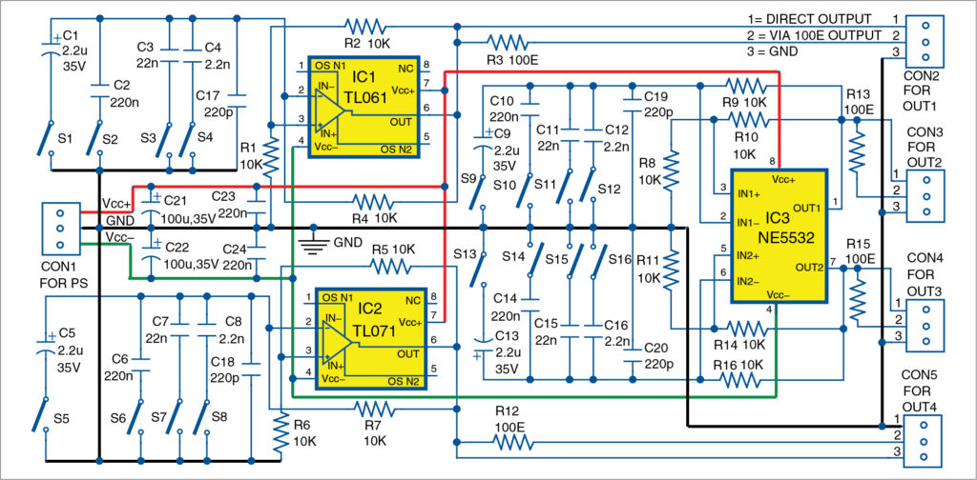 fig 4

The circuit is built around single op-amps TL061 (IC1) and TL071 (IC2), a dual op-amp NE5532 (IC3), sixteen on/off switches (S1 through S16) and a few extra components. This circuit can be used to test two single op-amps (IC1 and IC2) and one dual op-amp (IC3) conveniently. Sometimes, it can be difficult to choose whether to use two single op-amps or one dual op-amp in a project. In that case you need to compare parameters of the two single op-amps with those of dual op-amp. IC1 and IC2, and IC3 can be of the identical type, such as NE5534 and NE5532, correspondingly.

This circuit gives five test output frequencies on selecting switches S1 through S4. Test output frequencies for IC1 are given in the table below.

|  |  |  |  |
| --- | --- | --- | --- |
| When switch is closed | Select capacitor | Value of the capacitor | Approximate test output frequency |
| S1 | C1 | 2.2μF | 30HZ |
| S2 | C2 | 220nF | 300HZ |
| S3 | C3 | 22nF | 3kHZ |
| S4 | C4 | 2.2nF | 33kHZ |
| None | C5 | 220pF | 330kHZ |

Use S5 through S8 switches for testing IC2. Use S9 through S16 switches for testing IC3. For IC1 and IC2, the test frequencies can be same.

With the same or different frequencies, IC3 can be tested. Since IC3 is a dual-op-amp, there can be chances where one of the inbuilt op-amps of IC3 is damaged while the other op-amp is operational, and vice-versa. (Note: If the op-amp is damaged, you will not get output frequencies as listed in the table.

This circuit operates with a bipolar power supply. But IC1, IC2 and IC3 have the same power supply lines. Power supply can be symmetrical or non-symmetrical. This will change the limitations of output signals. The circuit operates in full power supply range of the op-amps. Maximum power supply is limited by driving capabilities, op-amps and maximum voltage rating of capacitors used in the tester circuit.

Output frequency of the tests can be changed easily to needs. Driving ability of the op-amps can be tested with external loads. Each op-amp under test has a direct output line as well as output with series resistor of 100 ohms. Op-amps will be unstable if we test them directly with inductive and capacitive loads, so 100-ohm resistors are provided at output.

The circuit does not require any adjustment to operate properly. It can be used to test many op-amps, including faster op-amps such as OPA132 and OPA134 and low-speed op-amps such as LM741 and MC1458.

**CHAPTER 5**

**HARDWARE DESCRIPTION**

The components required are as follows:

|  |  |  |
| --- | --- | --- |
| **SL NO** | **COMPONENTS** | **NUMBER OF COMPONENTS** |
| 1 | IC TL061 | 1 |
| 2 | IC TL071 | 1 |
| 3 | IC NE5532 | 1 |
| 4 | 10KΩ Resistors | 12 |
| 5 | 100Ω Resistors | 4 |
| 6 | 2.2μF Capacitors | 8 |
| 7 | 220nF Capacitors | 2 |
| 8 | 22nF Capacitors | 4 |
| 9 | 2.2μF Capacitors | 4 |
| 10 | 220pF Capacitors | 4 |
| 11 | 100μF Capacitors | 2 |
| 12 | Switches | 16 |
| 13 | 3 pin connectors | 5 |
| 14 | Power supply | ±5 to ±15 |
| 15 | Jumper wires | As required |

A detailed explanation about these elements are given as follows for better understanding of the circuit.

5.1 THE LOW POWER JFET OP-AMP:

IC number: TL061

In case the mentioned IC is not available, it can be replaced with the following ICs TL061A, TL061B, TL062, TL062A, TL062B, TL064, TL064A, TL064B.

The low power JFET single output amplifier consists of high speed, high voltage JFET and bipolar junction transistors. This operational amplifier is packed in a monolithic fashion.

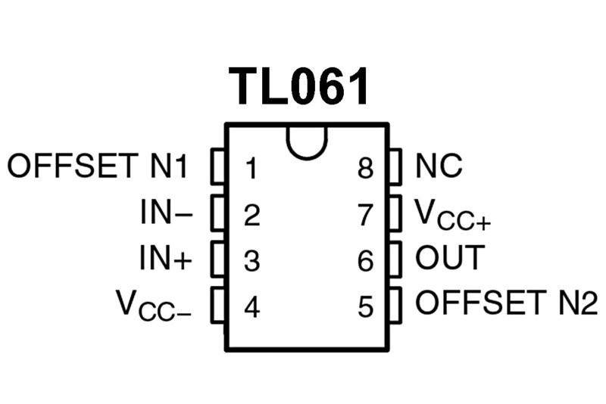

Fig 5.1

This operational amplifier as a few extraordinary features such as

* Very low power consumption: 200 µA
* differential voltage ranges and Wide common-mode (up to VCC+)
* Low input bias and offset currents
* Output short-circuit protection
* High input impedance JFET input stage
* Internal frequency compensation
* Latch-up free operation
* High slew rate: 3.5 V/µs

5.11 PIN DISCRIPTION:

|  |  |  |
| --- | --- | --- |
| **PIN NUMBER** | **NAME OF THE PIN** | **FUNCTION OF THE PIN** |
| 1 | Offset null-1 | Used to nullify |
| 2 | Inverting input | Input pin |
| 3 | Non inverting input | Input pin |
| 4 | GND | grounded |
| 5 | Offset null-2 | Used to nullify |
| 6 | output | Output pin |
| 7 | Vcc | Supply Voltage (5-18) V |
| 8 | No connection |  |

5.12 INTERNAL CIRCUIT DIAGRAM:

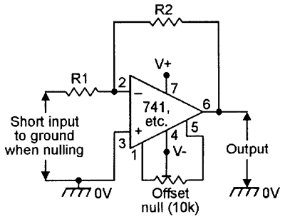

**Fig 5.11**

5.2 THE LOW NOISE JFET OP-AMP:

IC number: TL071

In case the mentioned IC is not available, it can be replaced with the following ICs TL071A, TL071B, TL072, TL072A, TL072B, TL074, TL074A, TL074B.

These ICs have relatively low input bias current and low offset currents. In addition to this the IC offers a high slew rate. Due to the low harmonic distortion and high noise cancelation this IC finds its application in audio preamplifiers and high fidelity. The design of this operational amplifier is fabricated into a monolithic chip.

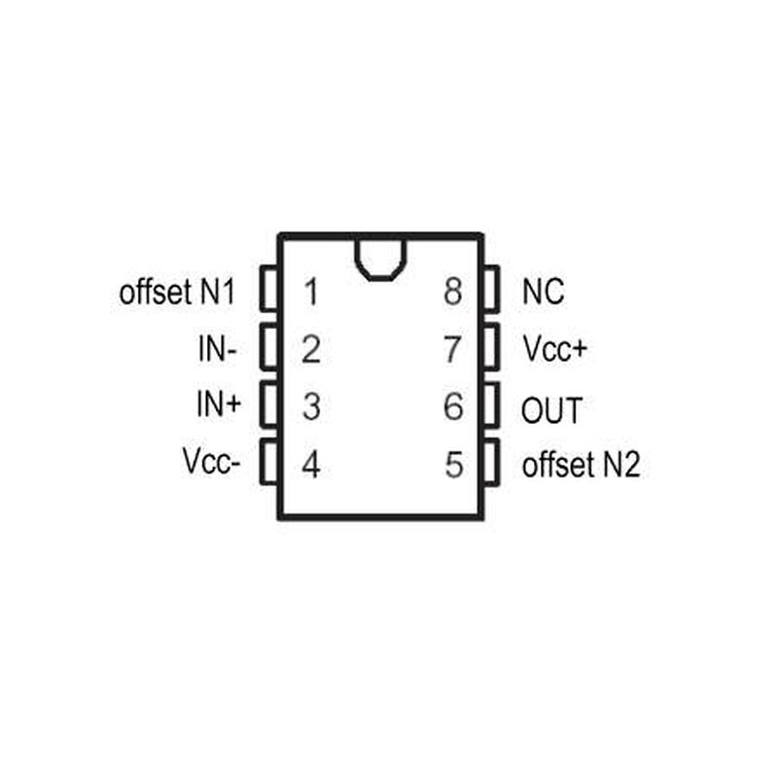

Fig 5.2

* Low Power Consumption
* Wide Common-Mode and Differential Voltage Ranges
* Low Input Bias and Offset Currents
* Output Short-Circuit Protection
* Low Total Harmonic Distortion typical value ranges up to 0.003%
* High Input Impedance offered by the JFET Input Stage
* Internal Frequency Compensation
* Latch-Up-Free Operation
* High Slew Rate is typically 13 V/µs

5.21 PIN DISCRIPTION:

|  |  |  |
| --- | --- | --- |
| **PIN NUMBER** | **NAME OF THE PIN** | **FUNCTION OF THE PIN** |
| 1 | Offset null-1 | Used to nullify |
| 2 | Inverting input | Input pin |
| 3 | Non inverting input | Input pin |
| 4 | GND | grounded |
| 5 | Offset null-2 | Used to nullify |
| 6 | output | Output pin |
| 7 | Vcc | Supply Voltage (5-18) V |
| 8 | No connection |  |

5.22INTERNAL CIRCUIT DIAGRAM:

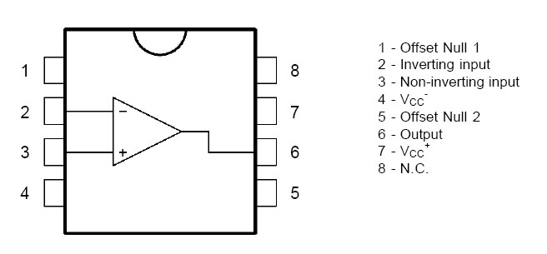

**Fig 5.21**

5.4 Resistors

Resistors used in circuit are 10kΩ and 100Ω. Resistor is a two-terminal device which is used in an electric circuit and provides predefined resistance to the flow of current in the circuit. The resistance of a resistor can be linear or non-linear depending on the application used. The resistance of a linear resistor is self-determined of the applied voltage. But the resistance of a non-linear resistor changes upon the applied voltage. Resistors made of semi-conductor are non-linear. However, resistors can also be used to control the amount of voltage provided to part of a circuit and to help create timing circuits.

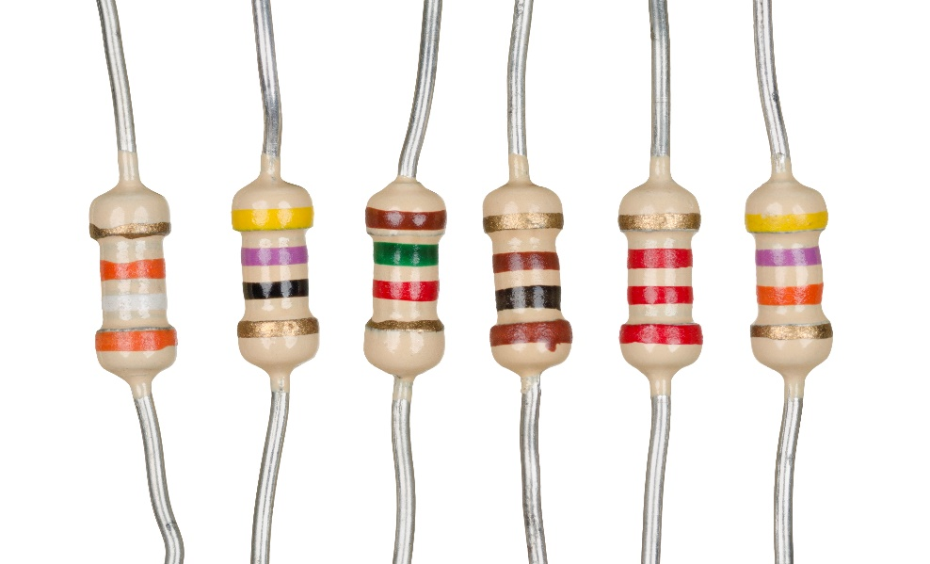

Colour coding is used in resistors to calculate the magnitude of the resistance in ohms.Colour coding is a process widely used in determining the values of the resistors. The colour bands on the resistor are of utmost significance while determining the value of the resistors. Each colour has a resistance value along with a tolerance value as shown in the figure mentioned below.

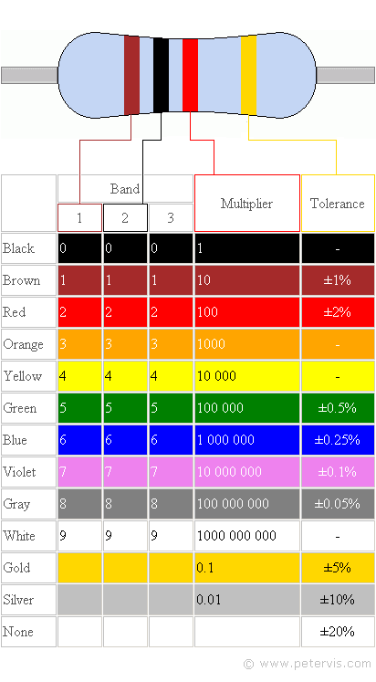

The colour code for 10k ohm will be: brown, black, orange, gold

The colour code for 100 ohm will be: brown, black, brown, gold

5.5 CAPACITORS:

Capacitors used in this circuit are 2.2μf, 220nf, 22nf, 2.2μf, 220pf, 100Μf. A capacitor is a

component that has the ability (capacity) to store energy in an electric field. It is an inactive

electronic module with two terminals. The charge that capacitor hold is known as

capacitance. Capacitors are devices which store & hold electrical charge. Further uses

include power conditioning, electronic noise filtering, decoupling or signal coupling and

remote sensing. Because of its wide-ranging applications, capacitors are used in a wide

range of industries and have become a vigorous part of everyday life.

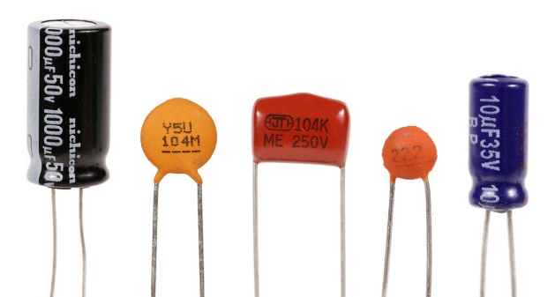

5.6 SWITCHES:

A switch is an element which controls the open-ness or closed-ness of an electric circuit. They let control over current flow in a circuit (without having to actually get in there and manually cut or splice the wires). Switches are the critical components in any circuit which requires user interaction or control. Electrical switches work according to an elementary design. Generally, the most common switches are the on/off toggle ones. Electric circuits work when electricity can move in a nonstop loop. The electricity slashes off once the circle is broken. This is where the switch comes in. when it is off, toggle on/off circuit breaks the current. The loop completes itself when it’s in” on” position.

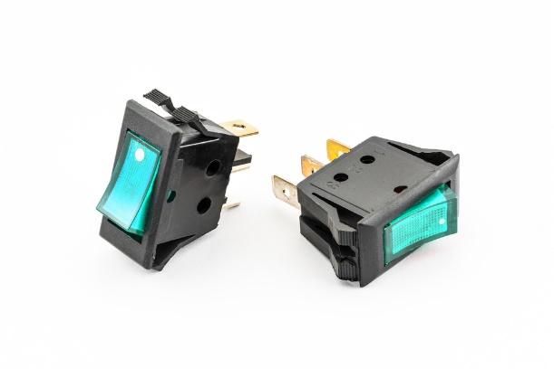

5.7 BREADBOARD:

The breadboard is a circuit construction system that is designed to allow the rapid creation

of circuits without the need for soldering or making permanent connections. Leaded

components are inserted into holes comprising metal grips that gently clamp onto the lead

and breadboards almost always have common rows whereby the holes in a row are

electrically connected together. Breadboards allow components to be inserted and removed

easily. To use a bread board, you just push the pins of jumper wires into the holes. The holes

have springs in them to keep the components from falling out. The trick, however, is to put

the pins into the right holes so that you get the circuit you want. Some of the holes in

breadboards are connected together and it is important to know which.

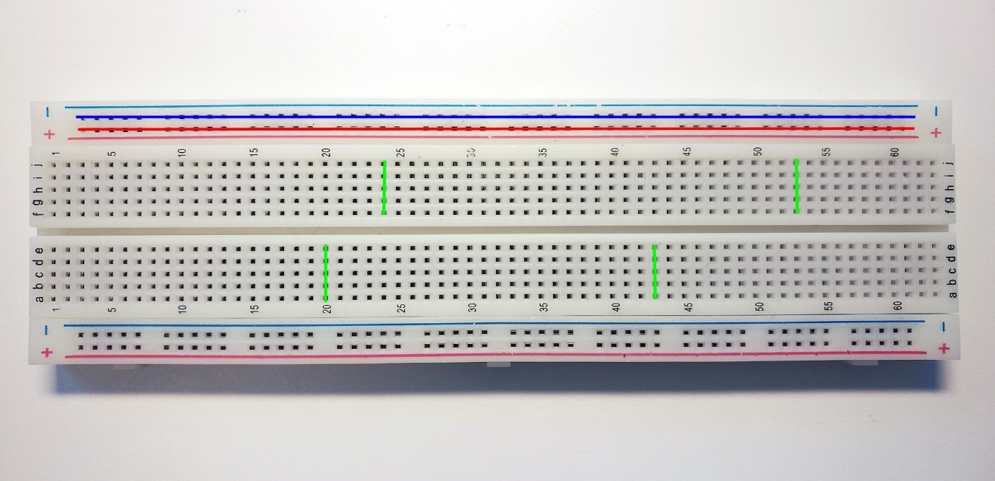

5.8 3-pin connector:

3 Pin Wire to Board connector are used commonly for connecting Wires to Boards. It

can be for Power Supply or connecting any other peripheral like Motor to the Board. There

is a distance of standard 2.54mm between two mounting pins, so that this connector can

be mounted easily on general purpose PCBs.

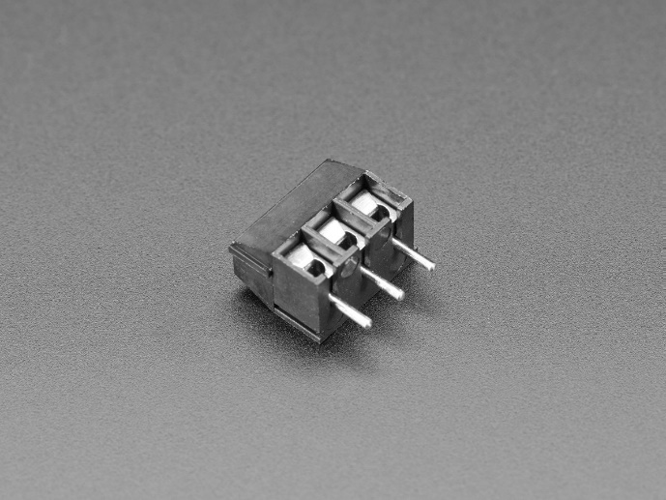

5.9 JUMPER WIRES:

A jumper wire is an electrical wire that has a connector or pin at each end which is usually used to interconnect the components of a breadboard or other prototype or test circuit, internally or with other equipment or components, without soldering. Individual jump wires are fitted by introducing the connector ends into the slots provided in a breadboard, the header connector of a circuit board, or a piece of test equipment.

The types of jumper wires:

The jumper wires are typically of three types:

The difference between the three types are based on their end of the wire. Basically, the male tip has a protruding end which is used to plug into things whereas, the females do not have protruding ends and cannot be used to plug into things.

* The male-to-male:

This is the most common type of jumper wire that is being used often. Our project also involves the use of this type of jumper wires. Especially while connecting two ports on a breadboard a male-to-male wire is useful.

Male-to-female:

The male to female jumper wire is useful in connecting female header pin of any board to a development board having a male connector.

1. Female-to-female:

This jumper wire is very much handy for making wire hardness on PCB’s.

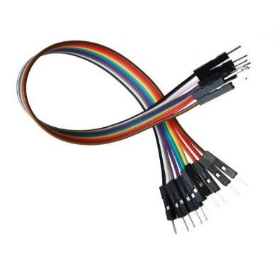

**CHAPTER 6**

**RESULT AND DISSCUSSION**

The result of this project was demonstrated successfully. By testing it on various ICs such as LM741, MC1458, OPA132, OPA134.

This project’s goal was to design a simple IC tester kit that allows the designer to check the working status of the IC before introducing it in a larger design. We have given our full efforts to make this mini project a successful tester.

**CHAPTER 7**

**ADVANTAGES AND APPLICATIONS**

**CHAPTER 8**

**CONCLUSION AND FUTURE SCOPE**

**REFERENCES**

[1]D. W. Bliss, P. A. Parker, A. R. Margetts, "Simultaneous transmission and reception for improved wireless network performance", *Statistical Signal Processing 2007 IEEE/SP 14th Workshop on*, pp. 478-482, 2007.

[2]https://www.google.com/search?q=Simple+Tester+For+operational+Amplifie&oq=Simple+Tester+For+operational+Amplifie&aqs=chrome..69i57j69i59.936j0j1&sourceid=chrome&ie=UTF-8

[3]https://bestengineeringprojects.com/operational-amplifier-741-tester/

**APPENDIX**